Clear Game Write Up

This document will address –

1. What the game is about
2. Core Gameplay Features
3. All the characters
4. Story Progression
5. The game world
6. The plot it’s self
   1. The World
   2. The Characters
      1. Enemy Types
      2. Protagonists / Antagonists
      3. Supporting characters
   3. The War
7. Cinematics
   1. Silent
8. Dialogue
9. Level Design

<https://www.youtube.com/watch?v=FuoK-Z3mTC4>

**I want to be able to merge between the two characters**

1. This game is an ancient tale where technology was a lot more advanced than now, and there has been a war that was sparked through years of humans imposing cruelty on the creatures that came to this world because theirs was destroyed. They came in peace and settled, but the humans didn’t enjoy this so they started being cruel and taking advantage of the creatures. One such tortured creature was night elf who went through much torture in her young age and has decided to rebel, she started an army and became the sole ruler of the creatures. They had an army and it kept growing as her magic portals allowed for creatures from the other side of the world to come and fight for her.

The game starts as you are a lead fighter in the great Salvian Army and you wake up, clearly from a blackout and the world is in chaos around you. The wall is on fire, explosions everywhere. Chaos, running around. You wake up and your arm is bleeding and your weapon near you, from this point the game begins. The world is in ruins, the fight is clearly over but something tells you that your army has won out this time. (Since the world is dynamic you will see people rebuilding now). Your friend comes over and helps you up and you follow your friend while taking in the beautiful view of being on the wall and seeing the dynamics and the world around you. You get saluted and people are re-building and many lay dead on the ground. You follow him up one of the towers to see your commanding officials who explain the game to you. When this happens you will zoom in on the map on the table where your mission is given to you and you are briefed on the task. You zoom into the map which converges into the world and you will fly above the entire world and see it’s beauty and then it disappears as you enter the world of the creatures, where it shows their army prepping, monsters coming through portals and it shows mainly the queen on her throne.

You and your friend set off with some materials, weapon of choice and some devices and most importantly the bomb. You manually go down into the entrance portion of the wall where the salute and let you go. The first stage is the tutorial of how to play the game, then you are set off.

This game follows you and another protagonist as you fight for your race’s freedom, by travelling the vast expanse of the world during the war to shut down the magic portals to allow the humans to have a fighting chance. As you travel across the vast landscape you will encounter many difficulties (survival is not one of them) including the armies against you, stealth and head on combat will be your biggest assets + the team work with your friend. You will encounter, rebellious clans, thieves, murderers and posted guards, even marching armies. Everything will be there already and make the game so beautifully immersive. It will all be dynamic, and combat can take place anywhere at anytime but it changes with the environment and AI will be very sophisticated (not joke AI).

There will be no side missions etc that will interfere with the main gameplay of the story, much like Journey there will always be a story being told through the beautiful environment and the players – the world that used to be. The thieves etc, will make your journey harder but there will still be no dialogue. For example, you may end up being knocked unconscious and wake up in a prison cell from which you have to escape, things like that can happen but all with the intent of making gameplay more fun.

I want environmental interactivity to be very high throughout the game, not like you can destroy it, but more like you can traverse any terrain like in assassins, creed. Even the biggest vertical rock has a way up (that’s why the ledge climbing system is important). The characters in the game also will have a big impact on gameplay and the non-verbal communication and the environment just needs to feel perfect to the wartime that is going on.

For weapons, you always have a default sword (as does your friend), but if you want more sophisticated weapons you will have to get them from the enemy when you kill them. For this you will have to sneak up on them before hand. You will have the ability to get smoke bombs, flash bombs, throw rocks, cause distractions, shoot flares etc, like in Counter Strike GO. Other stealth tactics can be picked up, like hanging off of things, sneaking up on them, slitting throats from the back all this fun stuff. There will always be things like enemy patrols on horses just coming around and you can detect if the come through the footstep noises and you will have to hide.

There will be an interactive medium between you and your friend, a menu of options on what to say for example. There are people there. Will change his behaviour or ‘Charge!!!’ things like that can change the way the game works. Or maybe I don’t need a friend at all, we will see if it makes the game too complicated or not…

Throughout the game you will be dealth with many challenges such as robbers trying to rob you, getting attacked by wild animals but good things can also happen like seeing people who are travelling and making trades with them for healing things, weapons and other such items

Although there will be no side missions directly as being assigned, there will be challenges and different things you will have to do in order for you to progress – so there will be a map and objectives. There will be a lot of players that you can talk to and side and inner stories – for example – your friend is hurt so you need a healer, but the healer has been taken by thieves etc.. Go break him out etc.. Which will all lead closer and closer – you can always interact with the environment to stealth your way through – There will always be places, for example the bridge which you will need to cross has enemy giants protecting it – you can take this the way you want.

## Core Gameplay Features

Remember : Minimalistic Design

* A very good combat system
  1. Dynamic and the player actually controls the combat like in OverGrowth
  2. Proper weapon physics
     1. Arrow dropping
     2. Sniper Time (not just a raycast)
     3. Proper punch reactions on the bones not just a pre-made animation

1. Very good environmental navigation
   1. Ability to traverse any type of environment and get to the top through climbing it.
2. Stealth Features are Important
   1. Flashes, Bombs, Distractions, Planting C4S, Creating Traps, Distractions
   2. Sneaking up behind etc…
   3. Taking enemy clothing, weapons etc..
3. Extremely good behaviour system
   1. Dynamic and **smart ai**
   2. The behaviour tree must have dynamic parts to allow it to be malleable
4. NPC Interactivity
5. Small Inventory system like seen on Unturned (simple)
6. Good Player Controller
   1. Smooth to move use Overgrowth animation technique
7. Environmental Interaction
   1. Ability to ride animals
   2. Drink water
   3. Walk in water
   4. Changes speeds on terrains
   5. Climb anything
   6. Winds Slow you Down
   7. Lens flare
8. Good story progressions
9. Cinematics and Trailers
10. Parkour Systems
11. Lots of exploration systems

## What makes this game fun?

You are on a quest that doesn’t involve side missions etc, you have one goal and you must reach it through stealth and combat. But most open world games have a vast emptiness. Every second of this game will have culture, enemies, power struggle, story, massive fantastical beasts that you will fight, **puzzles that you will have to solve**, complex stealth puzzles, animal riding and many friends and ai that will just join you for no reason and you won’t know if they’re evil or not. You can kill random NPC’s but this will lead to outrage of people or friends of that person and they may become hostile, see this is a dynamic world. There is a lot of wild life to explore where you can see parts of the story and attach them together. It also has very nice parkouring systems.

## Camera

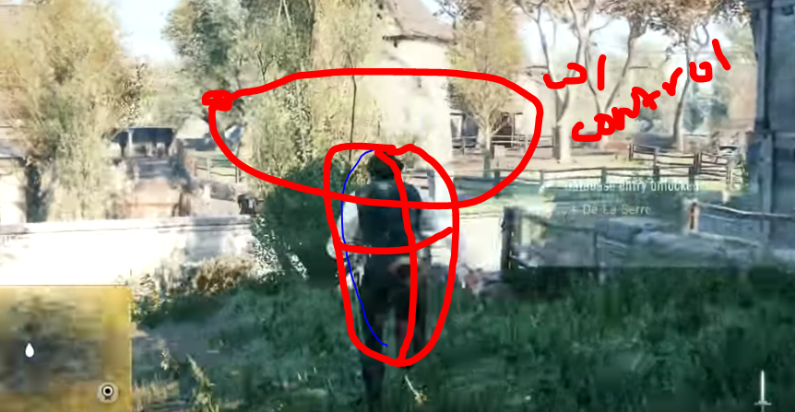

The player is centre of attention and camera can orbit him using controls. The players forward is always relative to camera but he doesn’t rotate until movement is give. TBH if ubisoft is using it, it must be right.

## Concept Characters

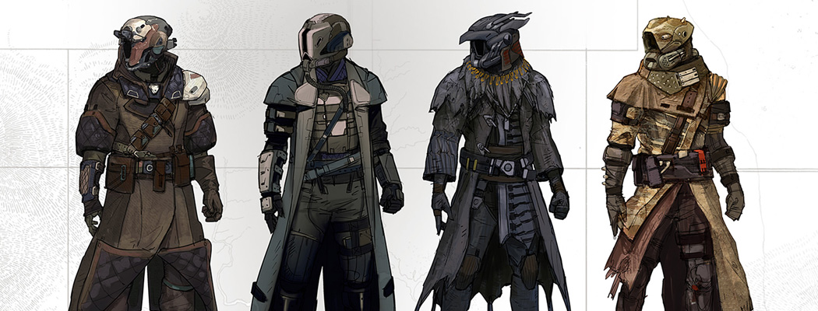

## The Communication

Communication between the two players is very important as they are the two protagonists and you as a player need to be able to control the NPC but the NPC shouldn’t just be a character who is there, he needs a presence that is almost identical to yours. He needs to be able to traverse the terrain with ease but also making mistakes and animations need to be even more accurate for him than the player.

The communication between the player cannot have voice interaction I want it to be a completely silent interaction so a menu will popup with dialogue options but when you click on the it will just be hand gestures.